RACE DOCUMENTS

NOTICE OF RACE (NoR) / SAILING INSTRUCTIONS (SI)

2022 Rags to Riches Regatta

July 2, 2022

Grayton Beach, Florida

RULES [NoR]
  - The regatta will be governed by the rules as defined in The Racing Rules of Sailing (RRS).
- NOTICE TO COMPETITORS [SI]
  - Notices to competitors will be posted on the official Notice Board Online (ONBO) at https://30a.com/rags-to-riches-regatta website. Competitors will be informed by text or email (indicated in the registration form) when a Notice to competitors is posted on the ONBO.

ELIGIBILITY AND ENTRY [NoR]
  - The regatta is open to all catamarans capable of being launched from the beach.
  - Boats without a rating will be assigned one based on US Sailing data.
  - A minimum of three (3) boats will constitute a fleet.
  - More information can be found at https://30a.com/rags-to-riches-regatta

FEES [NoR]
  - The entry fee is $45.00 per boat.

SCHEDULE [SI]
  - Race Day Events:
Check-In: 8:00 AM – 9:30 AM
Skippers Meeting: 10:00 AM First Warning: 10:55 AM

COURSES [SI]
  - The racing area will be located on the waters of the Gulf of Mexico.
  - The diagrams in Attachment A show the course, including the approximate angles between legs, the order in which marks are to be passed, and the side on which each mark is to be left.
- MARKS [SI]
  - Marks 1 and 2 will be green inflatable tetrahedrons. Start/Finish will be two orange flags on the beach, approximately parallel to the surf.
- COMMUNICATIONS [SI]
  - All boats should carry a VHF radio (if available) capable of communicating on channel 72. Channels 68, 69, and 71 may be used.
- START [SI]
  - All boats shall start on land in a line on the beach parallel to the water. The starting line shall consist of two orange flags on the beach, approximately parallel to the surf.
  - An alerting sound will be made thirty seconds prior to a cannon fired to start (amend RRS 26).
- FINISH [SI]
  - The finish shall be between two orange flags on the beach forming a gate, approximately parallel to the surf.

April 24, 2022 Page 1/2 R-to-R NOR-SI

- PENALTY SYSTEM [NoR]
  - RRS 44.1 is changed so that the Two-Turns Penalty is replaced by the One-Turn Penalty.
- HEARING REQUESTS[SI]
  - Hearing requests shall be filled by filling the form within the appropriate Time Limit.
  - The Protest Time Limit (PTL) shall be sixty (60) minutes after the last boat has finished. The resulting time will be posted at the Official Notice Board Online. (This changes RRS 61.3)
  - RRS Appendix T will apply.
- SCORING [NoR]
  - The Low Point System of Appendix A will apply.

PRIZES [NoR]
  - Prizes will be awarded to the boats with the highest scores in each fleet.
- DISCLAIMER OF LIABILITY

Competitors participate in the regatta entirely at their own risk. The Fort Walton Yacht Club, the organizing authority, will not accept any responsibility for material damage or personal injury, or death sustained in conjunction with or prior to, during, or after the regatta.

FURTHER INFORMATION
Regatta Website | https://30a.com/rags-to-riches-regatta
Event Organizer Kurtis Wolff | kurtis@cratertrain.com | 770-330-1167
Race Management John Farris | patssun@yahoo.com | 850-305-9653

- Attachment A [SI]

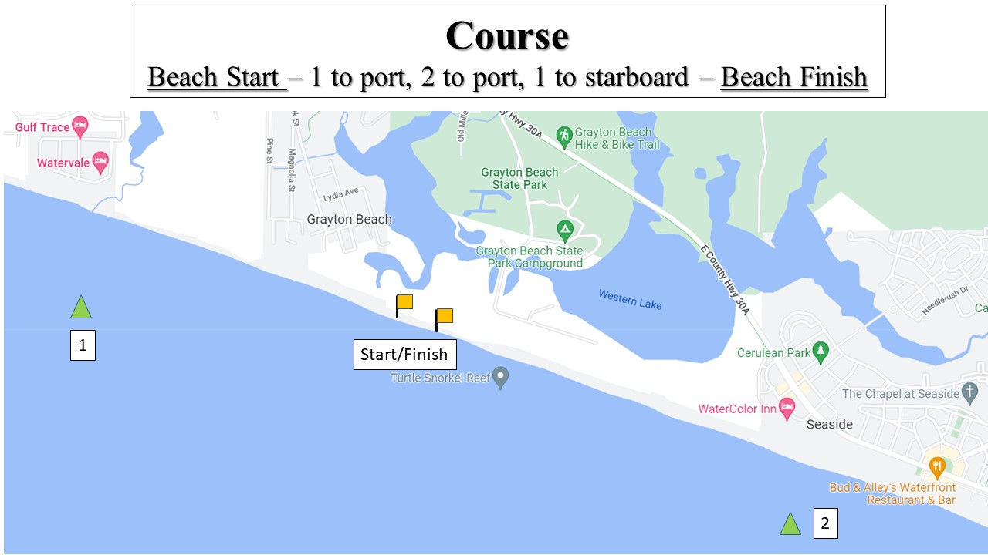

April 24, 2022 Page 2/2 R-to-R NOR-SI

